Abstract—…………………………………………………………………………………………………………………………………………………………………………………………………………………………………………………………………………………………………………………………………………………………………………………………………………………………………………………………………………………………………………………………….………………………………………………………………………………………………………………………………………………………………………………………………………………………………………………………………………………………….………………………………………………………………………………………………………………………………………………………………………………………………………………………………………………………………………………………….………………………………………………………………………………………………………………………………….
Investigation of Long Memory in Quarterly Home Price Index Data
Vikas Garg, Yasin Khan, Shirley Lu, Timothy Roberts, Yifan Tang, Wesley Tillu

IINTRODUCTION

N

Time Series Modeling
2.2
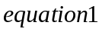

Methods

Data

Initial Analysis

Exploratory Data Analysis

Data Transformations
Many parameter estimators are based on the assumption of Gaussian distribution. In particular, the Whittle estimator for the fractional differencing parameter is one such estimator. The Whittle estimator is generally preferred over other fractional differencing parameters as it is consistent, unbiased, and asymptotically efficient.

The Box Cox transformation aims to apply a power transformation to ensure that the data follows an approximately normal distribution. The Box Cox transformation stabilizes variance and induces homoscedacity in the time series. It is defined as

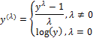

In practice, the observation ’s must be strictly positive. The simple returns series of the state-level housing price data include negative data points and thus, the absolute value of the minimum observed data value plus a small epsilon was added to each data point.

If the return series failed prior tests of normality, the Box Cox test was used to estimate the appropriate power of along with its standard error. Then, the interval () was evaluated to determine the power to apply. If the interval contained 0, a log transformation was used. Otherwise, the estimate or its closest fraction was used to transform the data.

The effectiveness of the data transformation was tested graphically with density plots and statistically using formal normality tests.

A weakness of the Box Cox transformation is that if the true distribution is far from Gaussian, there will not exist a sufficient that will make the data normal. However, even in cases where no power transformation could bring the distribution to exactly normal, the usual estimates of will lead to a distribution that satisfies certain restrictions on the first 4 moments, thus will be usually symmetric.

Results
Aggregate results

After individual state analysis, the state results were aggregated so that national or regional trends can be observed. The cumulative results can be analyzed from various perspectives and we explored numerous ways to partition the data such that we can gain insight into the United States housing market.

First, we examine whether the theoretical relationships with each predictor variable holds in our empirical results. As discussed in section III.D, population size, median income, and mortgage originations are expected to have a positive relationship with housing prices; unemployment rate, the 30-year commitment rate, and foreclosures are likely to have a negative relationship with housing prices; and building permits has either positive or negative relationship with HPI depending on the state and time.

Figure IV.1 shows the empirical associations of the predictor variables with state HPI, calculated based on the sign of the regression coefficients. Note that the percentage negative should be read as magnitude only with the negative sign left in to produce the graphs. As Figure IV.1 suggests, the majority of foreclosures, mortgage originations, population size, and unemployment rate observed relationships agree with the theoretical relationships. Interestingly, building permits has a positive association with HPI 80% of the time. This implies that as building permits, a supply side variable, increases, housing prices tend to increase. This suggests that building permits is more of a reaction to increasing demand than a expectation of future increasing housing demand.

The regression coefficients for median income and 30-year commitment rate, however, are not very informative as they are about 50%-50% positive and negative. As such, median income and 30-year commitment rate relationships were further analyzed by doing a cross-sectional breakdown, by geographical regions and by foreclosure levels.

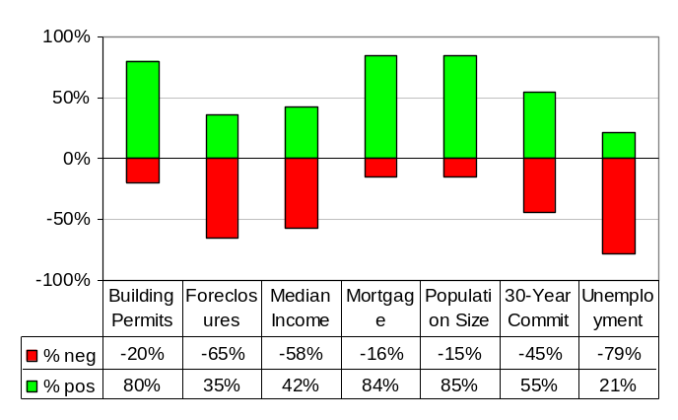
Figure IV.1: Percentage of positive and negative association between the predictor variables and HPI across 20 analyzed states.

The four main geographical regions of the U.S. are the Northeast, South, Midwest, and the West. The 20 analyzed states were sorted into their corresponding regions, and plots of these regions’ median income and 30-year commitment rate associations with HPI are shown in Figure IV.2.
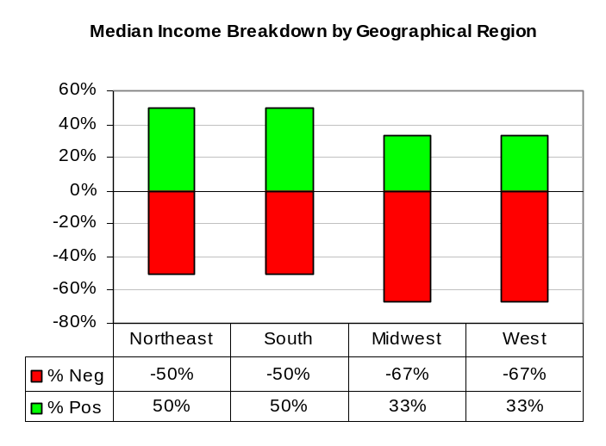
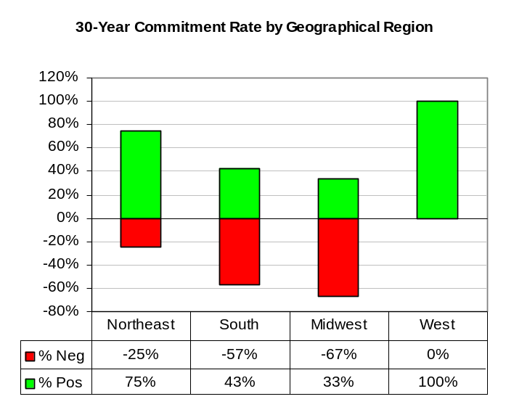
Figure IV.2: Median income (top) and 30-year commitment rate (bottom) associations’ breakdown by U.S. geographical region

From a geographical region perspective, the effect of median income and 30-year commitment rate on housing prices is not too clear. Median income levels seem to have less of an effect on the Midwest and Western states, relative to the Northeast and Southern states. The effect of 30-year commitment rate also appears to be a stronger indication of housing prices in the South and Midwest. However, since the sample size is only 20 states, these results may not be as robust. Also, the inconclusive association of median income and commitment rate can be attributed to the fact that these predictor variables were statistically insignificant in many of the analyzed states.

The investigation of median income and 30-year commitment rate by foreclosure level is more telling. Figure IV.3 shows this classification.

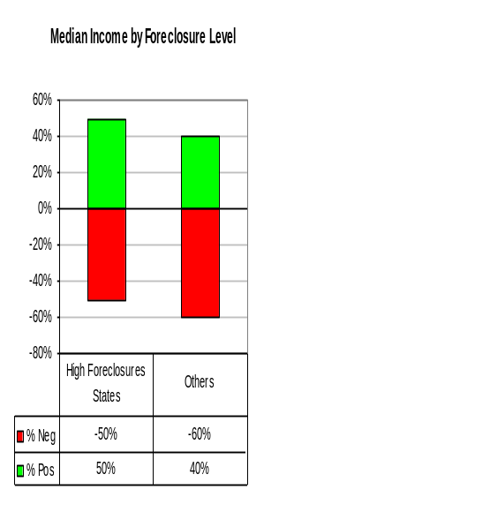
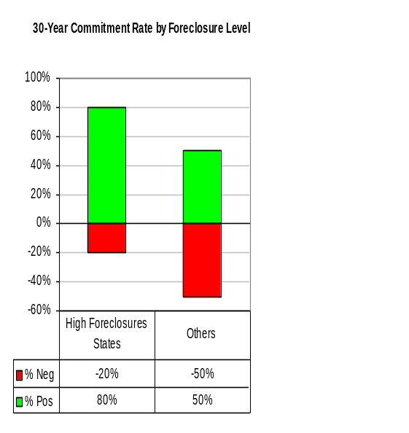
Figure IV.3: Median income (top) and 30-year commitment rate (bottom) associations’ breakdown by U.S. geographical region and foreclosure level

The association of median income remains weak. The correlation of median income and housing prices in states with lower foreclosure levels is slightly higher than that of higher levels. This could imply that homeowners in low foreclosure states use more of their median income, or cash, to purchase a home, rather than relying on borrowing and mortgages.

On the other hand, we can see that the 30-year commitment rate has a much higher effect on the states that experienced high foreclosure rates, relative to states with lower foreclosure levels. But this correlation is not consistent with theoretical relationships. The correlation between commitment rate and housing prices in high foreclosure states is mostly positive. This could imply that banks may hike rates to meet the increasing demand in mortgages. Long-term interest rates may also have less of en effect on the bubble states; it could be that these states were more influenced by shorter-term interest rates, since homeowners believed that they could easily refinance their mortgages.

As for states with average or below-average foreclosure levels, there is not a strong correlation between lending rates and housing purchases. Reasoning for this is that banks may increase rates if people are borrowing more, or if banks reduce rates, people will be incentivized to borrow more as well. As a result, the effect of interest rates can be either positive or negative on housing prices.

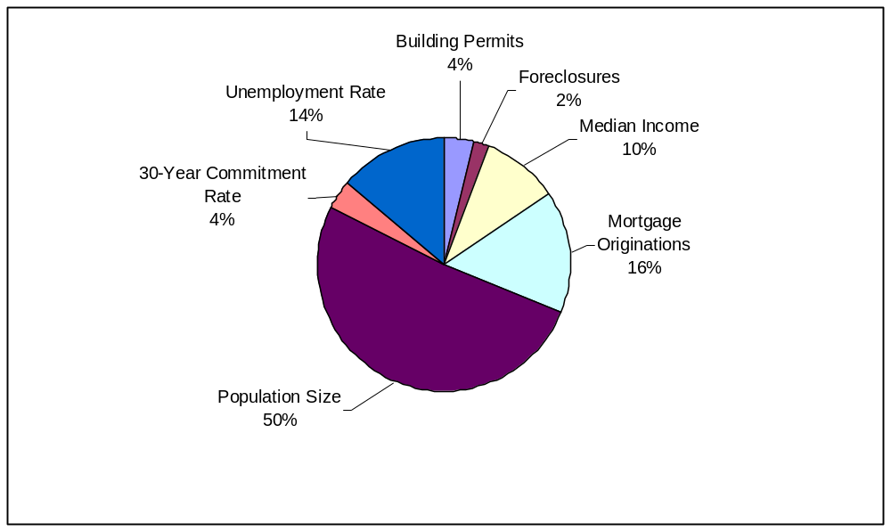
Figure IV.4: Strength of variable relationships across states as measured by average variable variance of total variation explained by model

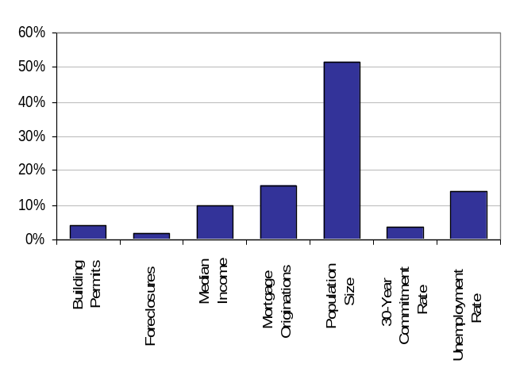

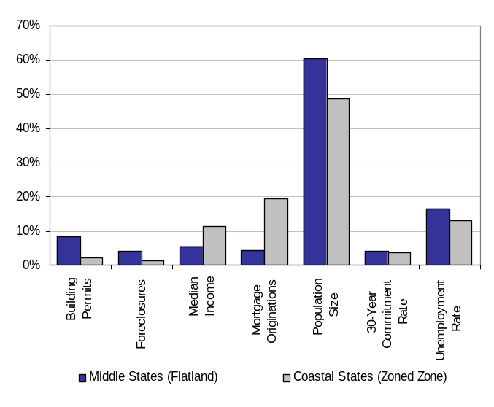

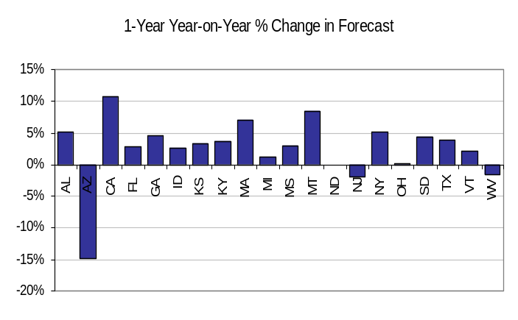
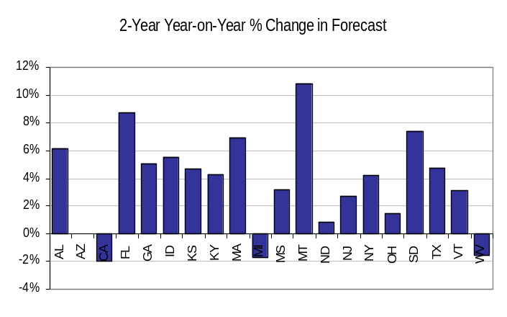
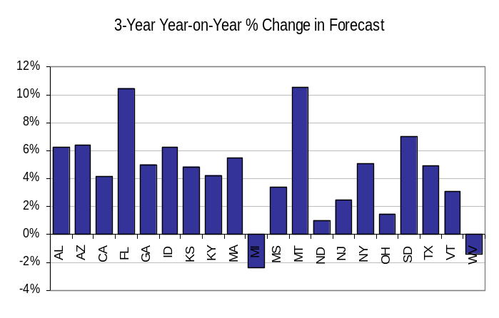

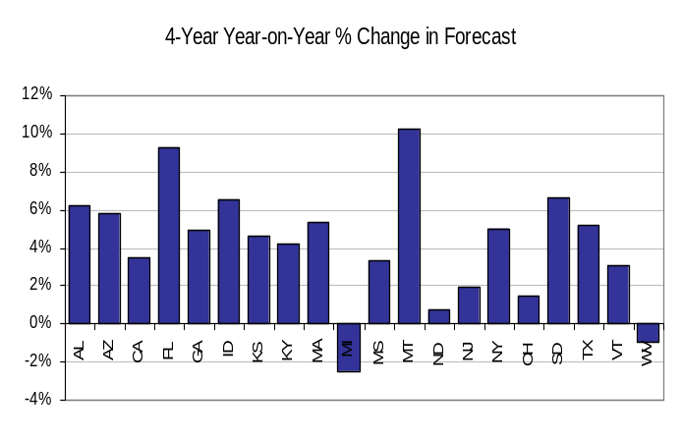
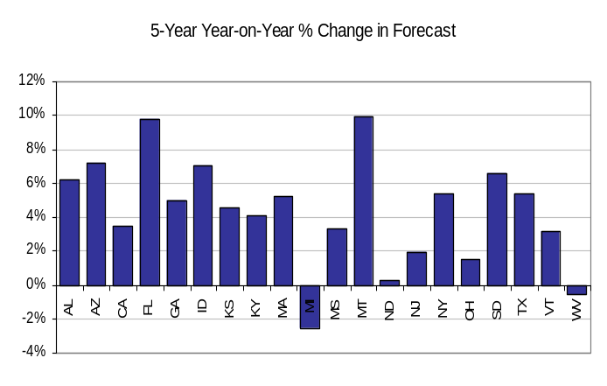
Aggregate Volatility Model Results

For the

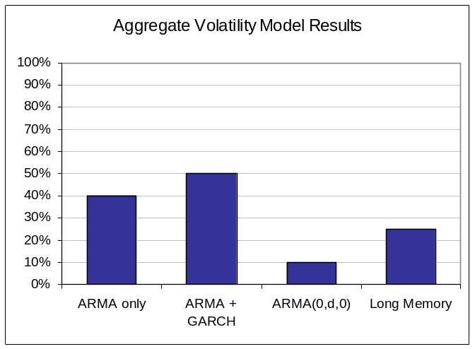
Figure IV.5: Aggregate Volatility Model Results Across States

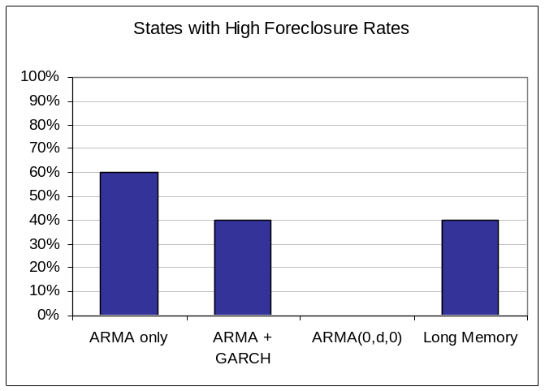
Figure IV.6: Volatility Model Results for States with High Foreclosure Rates

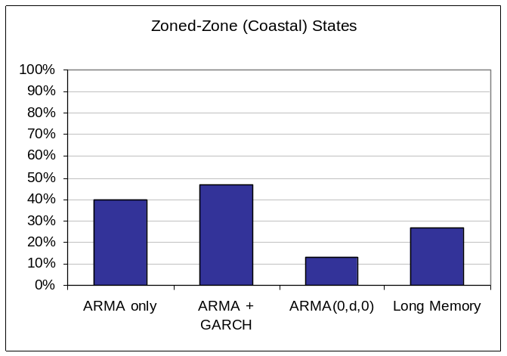
Figure IV.7: Volatility Model Results for Zoned-Zone Coastal States

Initial Analysis

Exploratory Data Analysis

Data Transformations
Analysis of the states demonstrated that the distribution of the returns deviates too far from Gaussian and thus, any Box Cox transformation attempt fails. Figure 4.x shows graphical results from before and after the transformation for Arkansas and Table 4.x. shows numerical results.
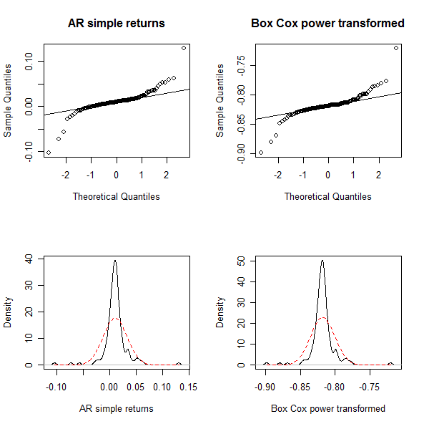
Figure 4.x: QQ plots and density plots of the Arkansas simple return series (left) and the Box Cox transformed series with =1.11 (right)

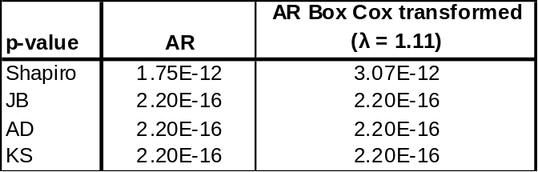
Table 4.x: p-values from normality tests for the Arkansas simple return series and the Box Cox transformed series with=1.11 (right)

The QQ plots and density plots show significant departures from normality. The p-values of various normality tests strongly suggest non-normal distributions. It is concluded that a Box Cox transformation is inadequate in making the return series Gaussian.

Florida

Why is Florida different?
The economics of the Florida real estate market is different from other states, especially the other bubble states such as California and Arizona. There are three main differentiations to point out: (1) international investors, (2) concentration of luxury million$ homes, and (3) abundance of vacation homes.

First, Florida’s housing market has a large percentage of international investors, and is ranked first of all foreign home-buying transactions at 26%. California, the second-ranked state, is more than 10% below Florida. Table xx shows the top five states for foreign home buyers, as compiled by the National Association of Realtors. Most of Florida’s housing’s international investors are from Europe and Latin and South America. Florida is a major gateway for visitors to the United States from other countries, and cash-rich international investors are attracted to the location, climate, and relatively cheap housing properties of Florida. This extra source of investors can buffer against any downward housing price pressure.

Table IV.1: Top Five State Destinations for
International Home Buying
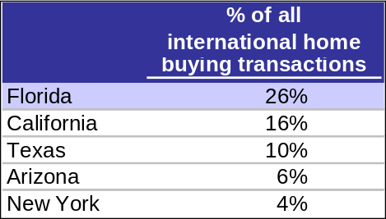

Second, Florida has some of the priciest homes in the nation with a large concentration of homes pass the million-dollar mark. These wealthy owners are less affected by the mortgage of credit problems that other Americans face. However, it is important to note that the OFHEO Housing Price Index does account for any homes greater than a value of $417,000. Nevertheless, the abundance of luxury homes attracts wealthy homeowners who may own other homes as well.

Finally, many Americans own vacation homes in Florida, which keeps a healthy stream of demand for houses. Florida is consistently ranked in the top three of an annual poll conducted buy Harris Corporation as where most people would like to live as shown in Table xx. Furthermore, people who own a vacation home are less likely to take on a speculative mortgage or a mortgage they cannot afford. These owners tend to have more cash than the average homeowner.

Table IV.2: Harris annual poll: “If you could live in any state in the country, except the state you live in now, what state would you choose to live in?”
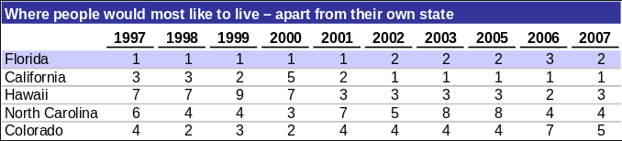

These characteristics of Florida’s housing market act as a safeguard for the prices of Florida houses, especially in times of declining prices.

Florida Outlook

Florida’s housing market peaked in 2005, before any other state in the U.S. Many real estates experts and analysts believe that Florida will also be the first to see a recovery as well. A popular expression for this belief is “First in, first out.”

Amongst the bubble states, our forecast and outlook for Florida is quite positive. There are optimistic outlooks for Florida’s population growth, unemployment rate, median income, and housing inventory, all of which are important predictors for Florida’s future housing prices.

Population growth is estimated to remain strong for the state. By 2010, Florida is forecasted to be the third most populated state in the nation. Florida’s population is expected to increase about 75% by 2030. An estimated 900 people move to the state every day.

Florida has the 4th largest labor force and its unemployment rate has been historically below national average for the past decade as shown in Figure xx.

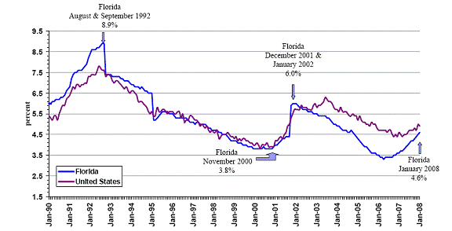
Figure IV.8: Seasonally Adjusted Unemployment Rates

Florida also has no state income tax. This gives an extra boost to median income.

There have been current signs of inventory reduction. Despite the fact that hundreds of foreclosed properties go on the market each month, the inventory of houses for sale is shrinking. There is current 12-month supply of inventory, down from a peak of 30 months. 3-6 months supply is typical of a healthy housing market.

Furthermore, steep price declines have encouraged first-time homebuyers with good credit, and lots of investors. Cash-rich international investors are also taking advantage of the depressed prices. First and second quarter 2009 has seen housing prices beginning to flatten out.

The forecast for Florida shows continued decreasing prices, but at slower rates until the end of 2009, and a recovery in mid 2010.

I(1) Testing

Normality Testing

Parameter Estimation for Model Building

Parametric vs Non Parametric vs Semi-parametric

Linear Time Series Parameters

Nonlinear Time Series Parameters

Fractional Differencing Parameters

Joint Estimation of ARFIMA Parameters

Model Checking and Performance

Absolute

Relative

Validity and Interpretation

Conclusion

Acknowledgment
References
- T. J. Barstow and Paul A. Mole. “Linear and nonlinear characteristics of oxygen uptake kinetics during heavy exercise,” American Physiological Society.
- Stephen Steiler. “The Lactate Threshold.” http://home.hia.no/~stephens/lacthres.htm
- Stirling, J. R., Zakythinaki, M., Refoyo, I., and Sampedro, J. “A Model of Hear Rate Kinetics in Response to Exercise.” Journal of Nonlinear Mathematical Physics. Vol 15. 2008
- Tsay, R. S. Analysis of Financial Time Series: Second Edition.

 

